Assignment 2- Introduction to SOC & Security Monitoring

Name- Samruddhi Dattu Nikam
PRN- 2124UCSF2019

Mini-Project: Local Telemetry Generation
This document outlines the tasks performed for the Local Telemetry Generation mini-project. The objective was to deploy a local virtual machine (Kali Linux), configure local logging utilities, generate five distinct security events, and verify their telemetry logs.

Part 1: Account Manipulation and Authentication Failure
Log Source: systemd journal (queried via journalctl)
The first phase of the task involved generating events related to user account creation and simulated login failures. The following actions were performed:
- Adding a new local user: A new user named 'attacker_account' was created using the useradd command.
- Simulating a failed login: An attempt was made to switch to 'attacker_account' using the 'su' command with an incorrect password, generating an authentication failure.
Key Log Fields Identified:
- Timestamp: Displayed in standard syslog format (e.g., Oct 04 15:51:54).
User: Identifiable via USER=root and UID fields within the log entry.
Process: Identifiable via the COMMAND= parameter (e.g., /usr/sbin/useradd).
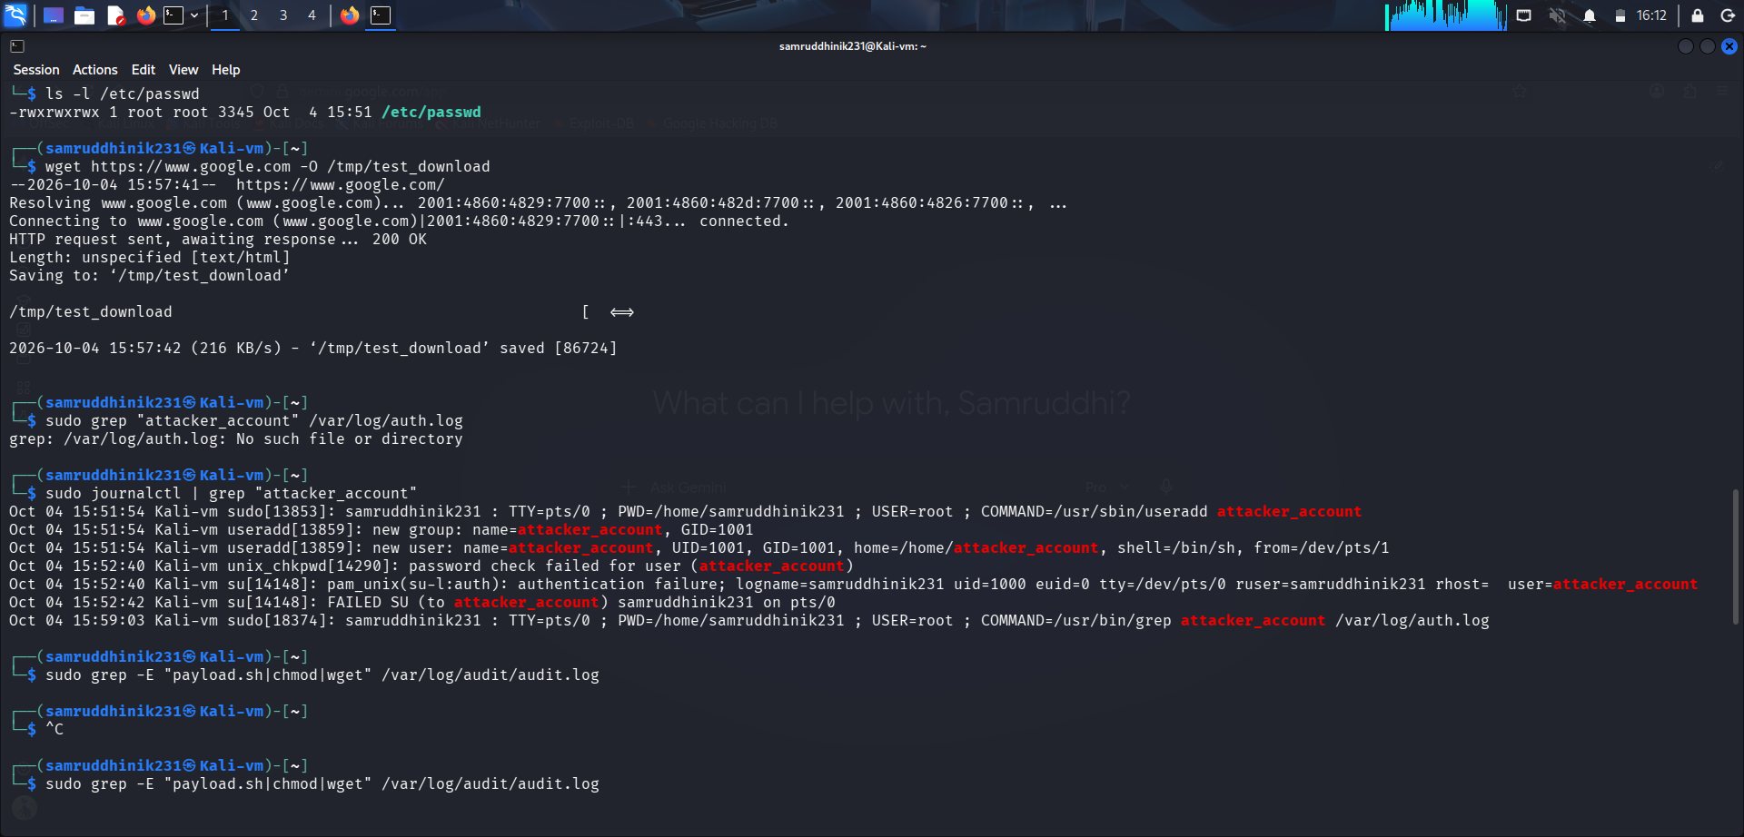

Part 2: File Modification, Network Activity, and Script Execution
Log Source: Audit daemon (/var/log/audit/audit.log)
The second phase involved monitoring system-level operations and command executions using auditd. The following actions were performed:
- Script Execution: Execution of a script named './payload.sh' was logged by the system.
- Privilege Modification: The permissions of the critical system file '/etc/passwd' were altered using the 'chmod 777' command.
- Network Download Activity: The 'wget' utility was used to download a file from an external source (https://www.google.com) to the /tmp directory.
Key Log Fields Identified:
- Timestamp: Displayed in epoch format inside the msg=audit(...) parameter.
User: Identified by auid (Audit User ID) and uid fields.
Process: Identified by the exe= field (e.g., exe="/usr/bin/chmod").
